# Scenario # 1: Game does not payout at correct level

## Scenario Description

When player wins on consecutive matches, but balance does not increase.

## Version Control

|  |  |  |  |
| --- | --- | --- | --- |
| Version # | Date | Author | Description |
| 0.1 | 12/10/2016 | Abhishek Gaba | Initial Draft |
| 0.2 | 13/10/2016 | Abhishek Gaba | Updated with buggy behavior screenshots and improved description. |

## Test Scripts

* Normal Play

## Use Case

Player wins in consecutive matches

## Test Components/Requirements

Dice

Game

Player

## Script # 1: Normal Play – Player Wins

### Script Description

Player (Fred) plays one match and wins consecutive turns, but his balance does not increase which means game does not payout correctly.

### Testing Requirements

Played with three identical dice with the faces of each dice marked with the symbols of a crown, anchor, heart, diamond, club and spade.

### Script Steps

| **Step #** | **Test Action** | **Expected Results** | **Pass/ Fail** |
| --- | --- | --- | --- |
| 1 | Dealers throws the dice |  |  |
| 2 | symbol appears on one or more of the uppermost face of the three dice |  |  |
| 3 | Player wins in consecutive turns | Balance should add | FAIL |

### Output from the Automated Test

Figure 1 shows that Fred won in turn 22,23, and 24 but balance didn’t increase.

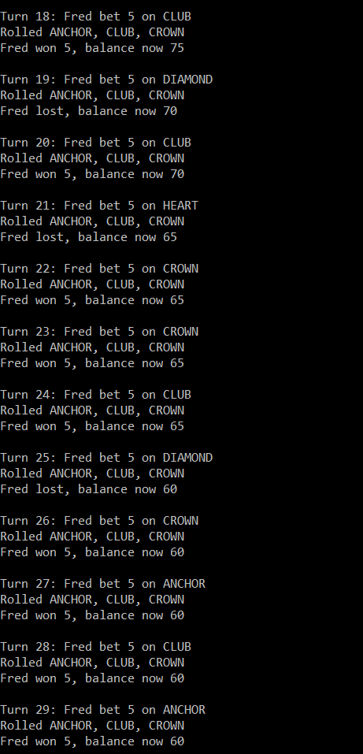

Figure 1 - Bug1

# Scenario # 2: Player cannot reach betting limit

## Scenario Description

Limit set to 0, but game ends with player still with 5 (dollars) remaining.

## Version Control

|  |  |  |  |
| --- | --- | --- | --- |
| Version # | Date | Author | Description |
| 0.1 | 12/10/2016 | Salman Ahmed | Initial Draft |
| 0.2 | 13/10/2016 | Salman Ahmed | Improved text, added bug reproducing screenshots. |

## Test Scripts

* Player cannot reach betting limit

## Use Case

Player lose

## Test Components/Requirements

Dice

Game

Player

## Script # 1: Normal Play – Player cannot reach betting limit

### Script Description

Player (Fred) plays one match and loses but game ends besides limit is set to 0 and Fred still have a balance of $5.

### Testing Requirements

Played with three identical dice with the faces of each dice marked with the symbols of a crown, anchor, heart, diamond, club and spade.

### Script Steps

| **Step #** | **Test Action** | **Expected Results** | **Pass/ Fail** |
| --- | --- | --- | --- |
| 1 | Dealers throws the dice |  |  |
| 2 | Symbol didn’t appear on one or more of the uppermost face of the three dice |  |  |
| 3 | Player loses in consecutive turns |  |  |
| 4 | Player balance is $5 and should be allowed another turn | Player should have another turn | FAIL |

### Output from the Automated Test

Figure 2 shows that Fred still have a balance of $5 after 40 turns but game ends.

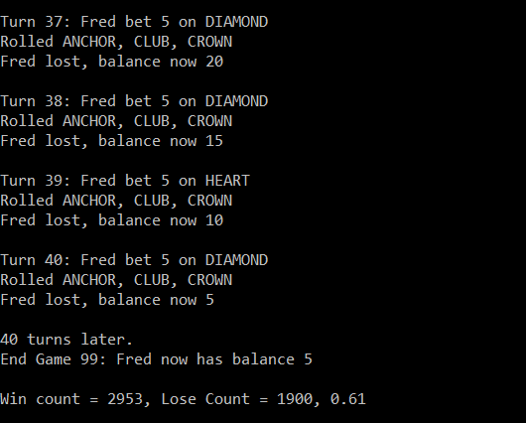

Figure 2 - Bug2

# Scenario # 2: Odds in the game do not appear to be correct.